Supplementary Material
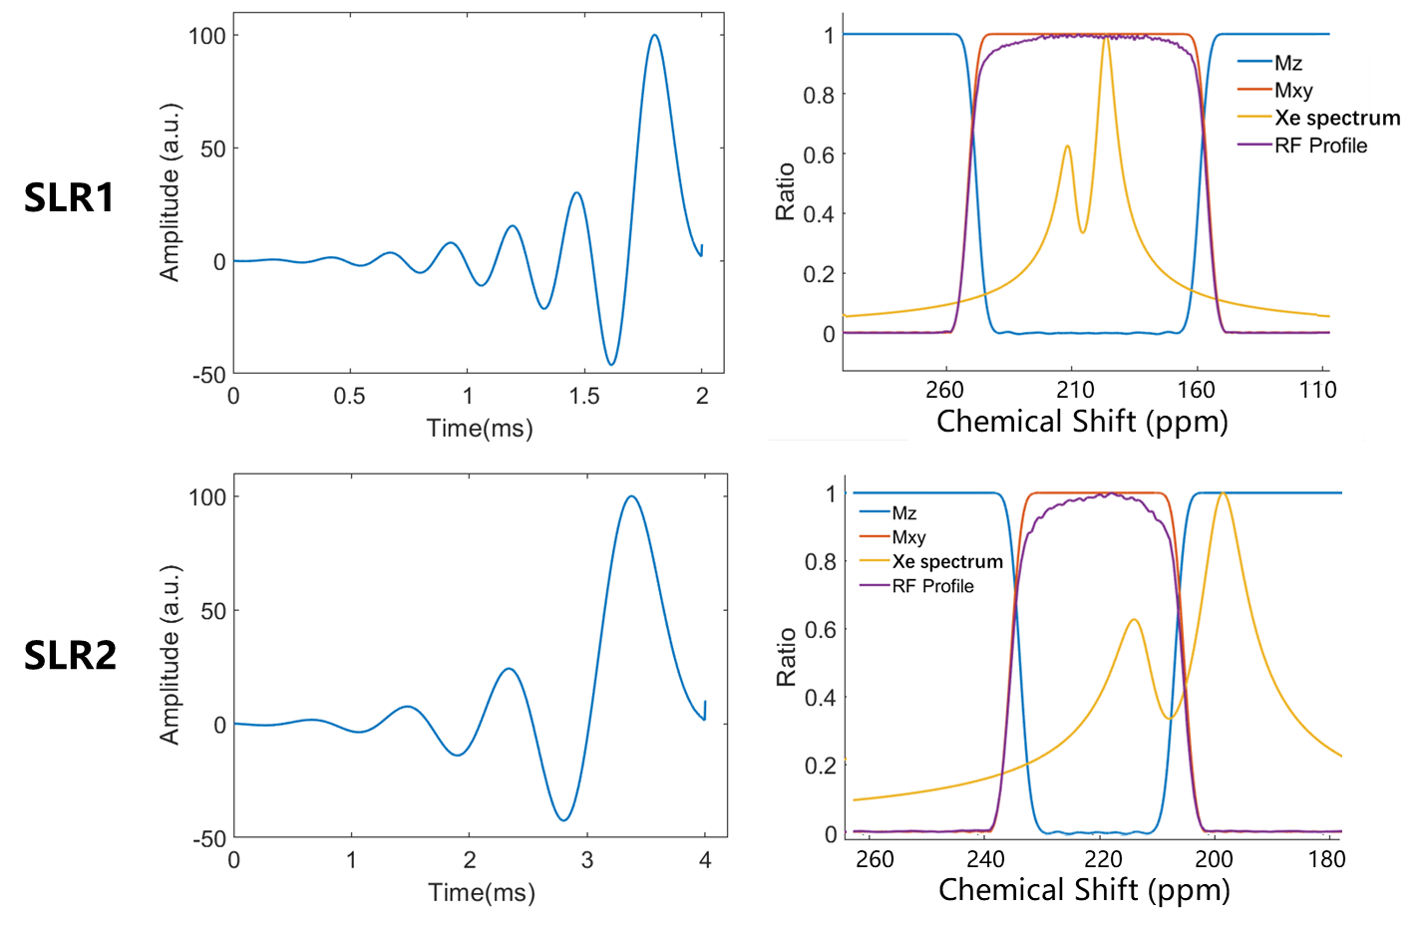
Figure S1. Temporal profiles of the SLR1 and SLR2 pulses and their frequency-domain excitation profiles. The yellow line represents the ¹²⁹Xe MR signal, while the blue and red lines represent the M𝑧 and M𝑥𝑦 profiles of the pulse excitation in the frequency domain, respectively. The purple line shows the measured frequency response of the pulse on a water phantom.

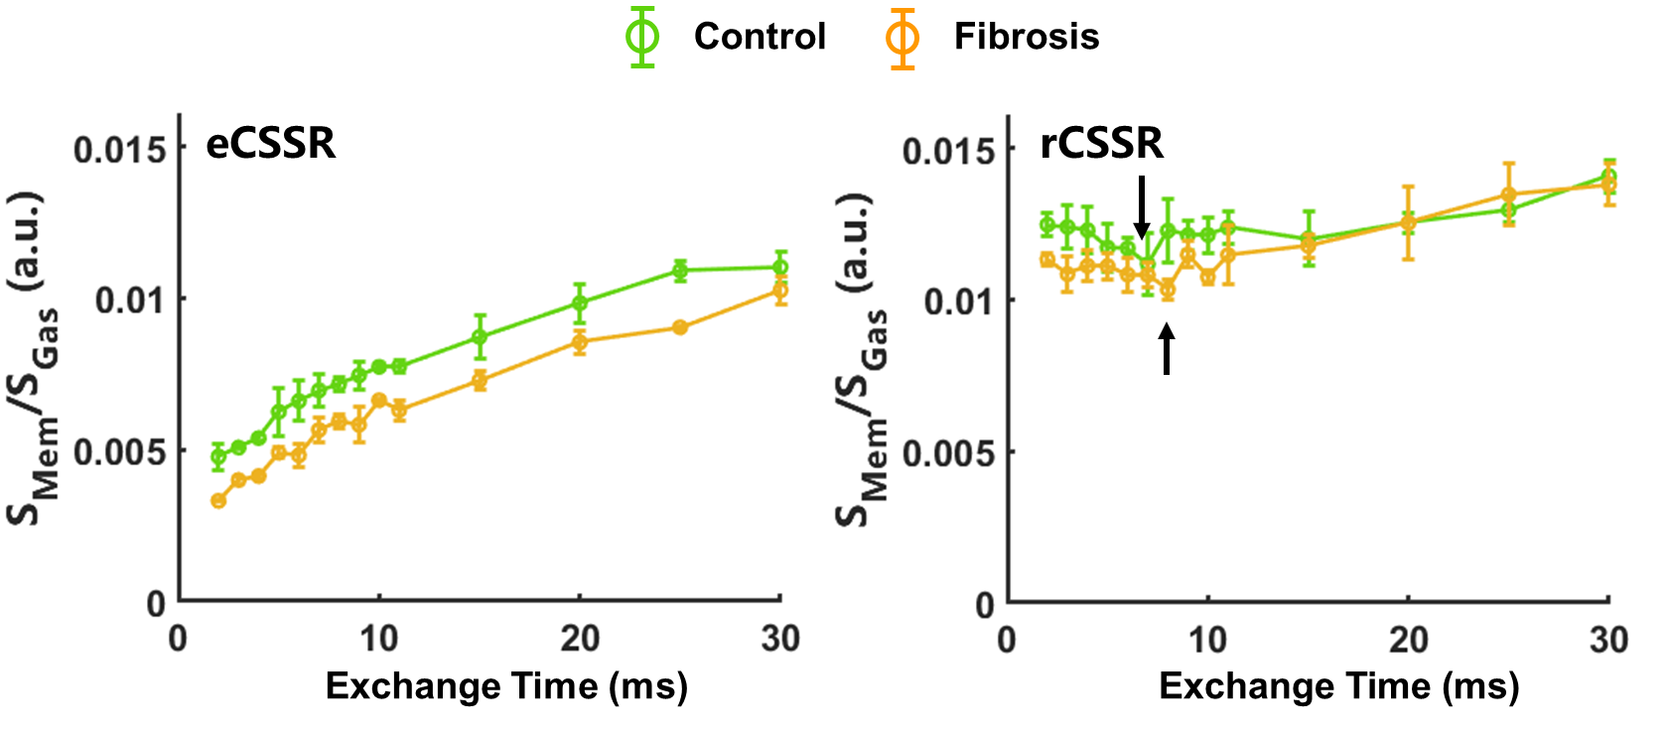
Figure S2. The S_{Mem}/S_{Gas} ratio as a function of exchange time for both eCSSR and rCSSR sequences. In eCSSR, the ratio increases progressively with exchange time, whereas in rCSSR, it shows an initial dip at very short exchange times before gradually rising.

